# 

# **Operating System Lab Assignment V**

### **4ITRC2**

*Purvanshi patidar*

*BE II Year*

*Information technology – ‘A’*

# Aim

To create C programs for the different scheduling algorithms.

# To perform

Create and execute C programs for following CPU Scheduling Algorithms:

1. First Come First Serve (FCFS)

2. Shortest Job First (SJF)

3. Round Robin Scheduling

# To Submit

C Codes for the above scheduling algorithms with their outputs.

## **First Come First Serve (FCFS)**

### Program:

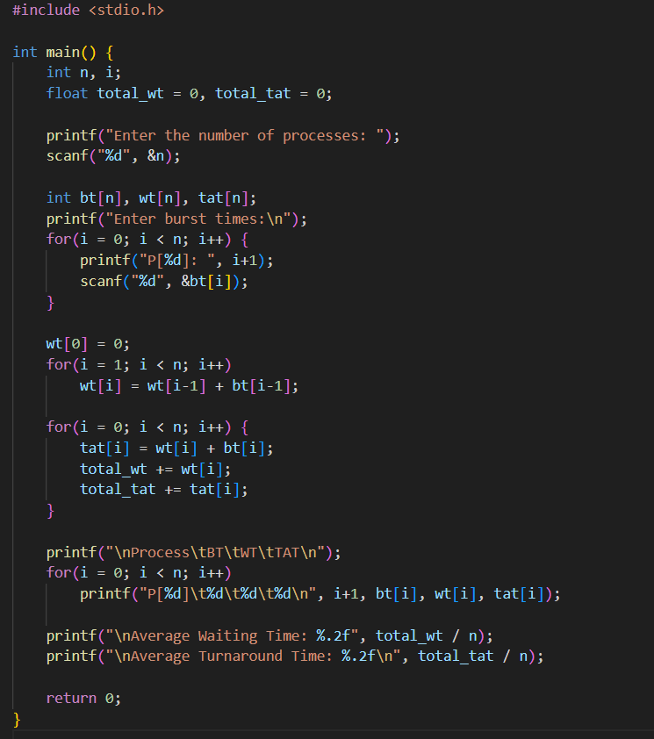

### Sample Output:

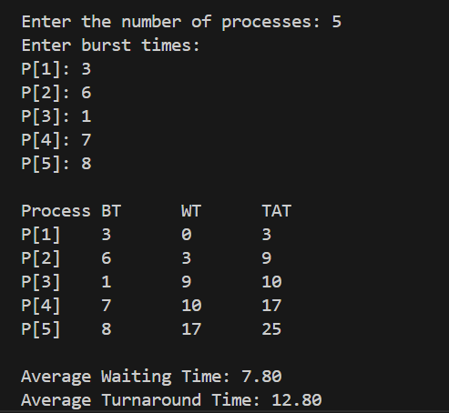

## **Shortest Job First (SJF)**

### Program:

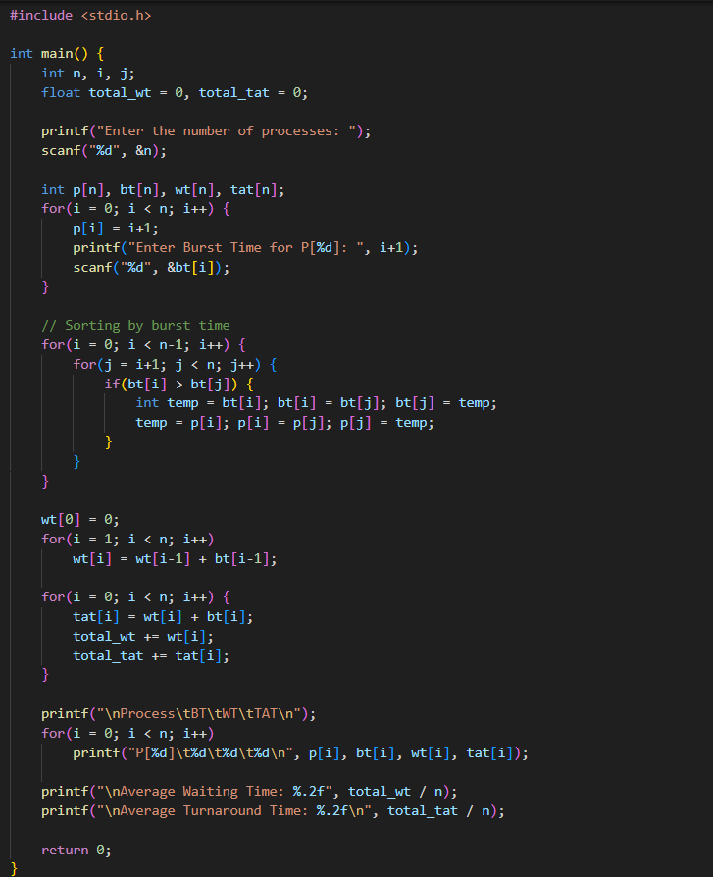

### Sample Output:

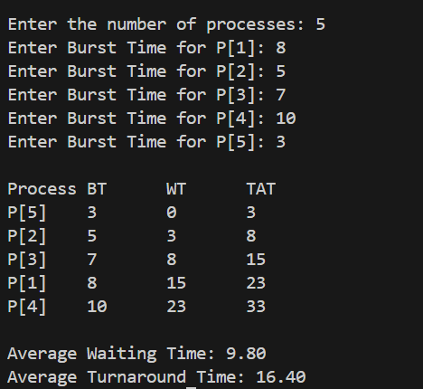

## **Round Robin Scheduling**

### Program:

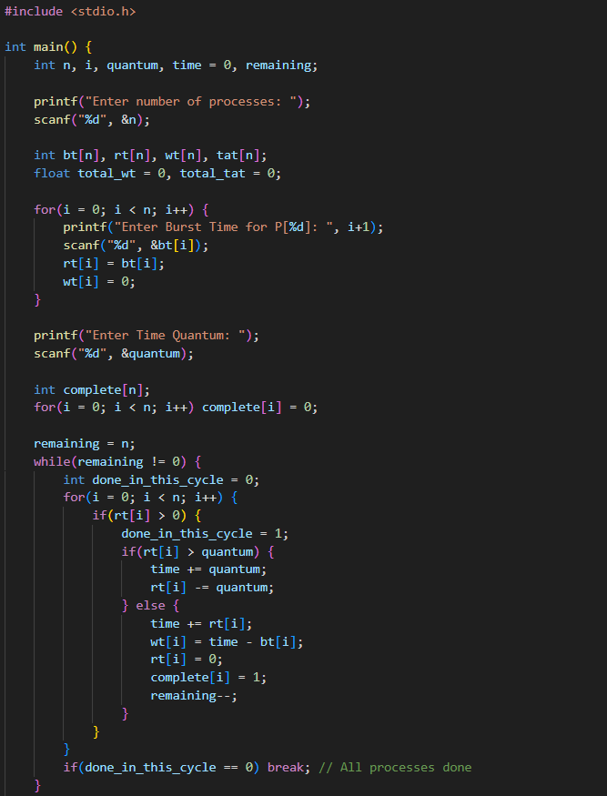

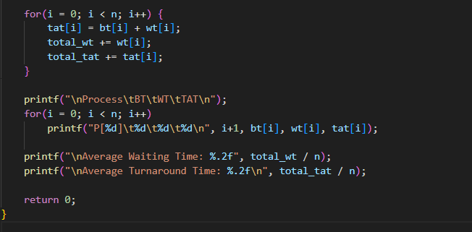

### Sample Output:

